USB docking system driver Guide

Build instructions:
Install WDK 7600.16385.1
Open Program Files -> Window Driver Kit -> WDK 7600.16385.1 -> Build Environment -> x64 free build environment,
Change folder to driver source at \src.wdk.vista\sys\
Enter build command “build –cZ”

Code Signing using GlobalSign cross certificate for Windows 7 64 Bit
- Ensure the GlobalSign Root certificate is removed from the certificate store on the local machine. If the GlobalSign Root is present, Signtool will fail to embed the cross certificate.
- Ensure the cross certificate is available to the Signtool application.
- Ensure the GlobalSign ObjectSign end entity certificate is available in the local certificate store.
One of the requirements for cross certificates to be used is that the GlobalSign Root CA is removed from the Root certificate store on the signing machine. (If the root is present, Signtool will place the root certificate into the chain which is incorrect for Vista/Windows 7 Kernel drivers.) Vista/Windows 7 has a fully automated certificate install capability that ensures the GlobalSign root certificate is always re-installed.

How to remove the GlobalSign Root Certificate
At the command prompt run the MMC (Microsoft Management Console) by typing certmgr.msc to ensure the GlobalSign Root CA is removed. i.e. Both ‘Issued To’ and ‘Issued By’ GlobalSign Root CA
Ideally, remove any instances of the GlobalSign RootCA that may also be in the Personal and Intermediate certificate stores as shown below.
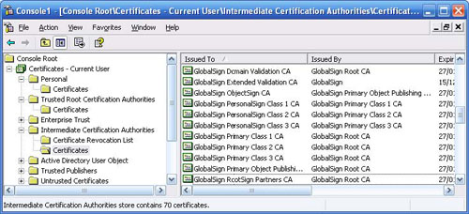

Where do I get the Cross Certificate?
The Cross certificate is located here:- http://www.microsoft.com/whdc/winlogo/drvsign/crosscert.mspx#EMG
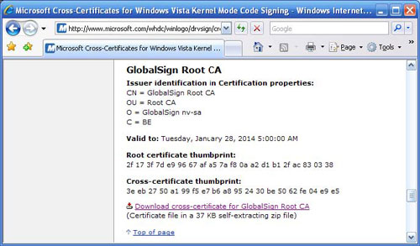

Where do I get the latest Signtool?
The WDK (Windows Driver Kit) and Windows Logo Kit is available on http://www.microsoft.com/whdc/devtools/WDK/AboutWDK.mspx

How do I know that Signtool supports Cross certificates?
Run signtool sign and check the /ac option is supported
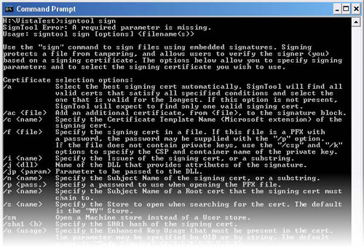

How do I sign my file?
Windows 7 64-bit signing steps (updated February 18, 2014):
1. Import .pfx file into your keystore by double clicking & starting the import wizard. Make sure to mark the key as exportable.

2. Delete all instances of the GlobalSign Root certificate from both the Local user account & the Computer account. You can do this through the MMC console.

3. Import the Microsoft Cross Certificate into your Computer account & Local user account in the MMC console.
This cross certificate chains our GlobalSign certificate back to the Microsoft Root which will validate the drivers. You can find the cross-certificate at this following location:

http://msdn.microsoft.com/en-us/library/windows/hardware/dn170454(v=vs.85).aspx

Scroll down and find the one under the GlobalSign CA.
When you use the /ac option during the signing process, you will specify the file name of that cross-certificate.
Download the file "GlobalSign Root CA.crt". Import to MMC before signing with /ac option by double click the .crt, there is button "install certificate". Click that install certificate button. This will put it on your user account.

Verify that .sys pass signtool verification against the cat file:
Sample command line is:
signtool.exe verify /kp /c C:\Users\globalsign\CDAS2-64-0206\CDAS2-64_0206\cvusb64.cat C:\Users\globalsign\CDAS2-64-0206\CDAS2-64_0206\cvisionusb.sys

4. Sign driver. When signing from the certificate store, instead of specifying a .pfx file with /f, you can simply use the command /a which will select the best and valid certificate from your store.

For example:

SignTool sign /ac AbcCrossCertificate.cer /a /t http://timestamp.globalsign.com/scripts/timstamp.dll AbcCatFileName.cat

C:\cv\SVN-usb\BULKUSB\installation.Win7.x64.Signed\XP-cv\cv>.\SignToolac.exe sign /v /ac "GlobalSign Root CA.crt" /a /t http://timestamp.globalsign.com/scripts/timestamp.dll CDAS2-64_0207\cvisionusb.sys
The following certificate was selected:
Issued to: CapsoVision Inc.
Issued by: GlobalSign CodeSigning CA - G2
Expires: Wed Mar 18 12:56:03 2015
SHA1 hash: 1EB8D4F044F37A584A959C4CB160FA3D61F8E7CB

Cross certificate chain (using machine store):
Issued to: Microsoft Code Verification Root
Issued by: Microsoft Code Verification Root
Expires: Sat Nov 01 05:54:03 2025
SHA1 hash: 8FBE4D070EF8AB1BCCAF2A9D5CCAE7282A2C66B3

Issued to: GlobalSign Root CA
Issued by: Microsoft Code Verification Root
Expires: Thu Apr 15 12:05:08 2021
SHA1 hash: CC1DEEBF6D55C2C9061BA16F10A0BFA6979A4A32

Issued to: GlobalSign CodeSigning CA - G2
Issued by: GlobalSign Root CA
Expires: Sat Apr 13 02:00:00 2019
SHA1 hash: 9000401777DD2B43393D7B594D2FF4CBA4516B38

Issued to: CapsoVision Inc.
Issued by: GlobalSign CodeSigning CA - G2
Expires: Wed Mar 18 12:56:03 2015
SHA1 hash: 1EB8D4F044F37A584A959C4CB160FA3D61F8E7CB

Done Adding Additional Store
Successfully signed and timestamped: CDAS2-64_0207\cvisionusb.sys

Number of files successfully Signed: 1
Number of warnings: 0
Number of errors: 0

C:\cv\SVN-usb\BULKUSB\installation.Win7.x64.Signed\XP-cv\cv>.\SignToolac.exe sign /v /ac "GlobalSign Root CA.crt" /a /t http://timestamp.globalsign.com/scripts/timestamp.dll CDAS2-64_0207\cvusb64.cat
The following certificate was selected:
Issued to: CapsoVision Inc.
Issued by: GlobalSign CodeSigning CA - G2
Expires: Wed Mar 18 12:56:03 2015
SHA1 hash: 1EB8D4F044F37A584A959C4CB160FA3D61F8E7CB

Cross certificate chain (using machine store):
Issued to: Microsoft Code Verification Root
Issued by: Microsoft Code Verification Root
Expires: Sat Nov 01 05:54:03 2025
SHA1 hash: 8FBE4D070EF8AB1BCCAF2A9D5CCAE7282A2C66B3

Issued to: GlobalSign Root CA
Issued by: Microsoft Code Verification Root
Expires: Thu Apr 15 12:05:08 2021
SHA1 hash: CC1DEEBF6D55C2C9061BA16F10A0BFA6979A4A32

Issued to: GlobalSign CodeSigning CA - G2
Issued by: GlobalSign Root CA
Expires: Sat Apr 13 02:00:00 2019
SHA1 hash: 9000401777DD2B43393D7B594D2FF4CBA4516B38

Issued to: CapsoVision Inc.
Issued by: GlobalSign CodeSigning CA - G2
Expires: Wed Mar 18 12:56:03 2015
SHA1 hash: 1EB8D4F044F37A584A959C4CB160FA3D61F8E7CB

Done Adding Additional Store
Successfully signed and timestamped: CDAS2-64_0207\cvusb64.cat

Number of files successfully Signed: 1
Number of warnings: 0
Number of errors: 0

C:\cv\SVN-usb\BULKUSB\installation.Win7.x64.Signed\XP-cv\cv>.\SignToolac.exe verify /v /kp CDAS2-64_0207\cvusb64.cat

Verifying: CDAS2-64_0207\cvusb64.cat
Hash of file (sha1): 434897DB81A5B47170CF9B9FFD9DBF281D5DAF15

Signing Certificate Chain:
Issued to: GlobalSign Root CA
Issued by: GlobalSign Root CA
Expires: Fri Jan 28 04:00:00 2028
SHA1 hash: B1BC968BD4F49D622AA89A81F2150152A41D829C

Issued to: GlobalSign CodeSigning CA - G2
Issued by: GlobalSign Root CA
Expires: Sat Apr 13 02:00:00 2019
SHA1 hash: 9000401777DD2B43393D7B594D2FF4CBA4516B38

Issued to: CapsoVision Inc.
Issued by: GlobalSign CodeSigning CA - G2
Expires: Wed Mar 18 12:56:03 2015
SHA1 hash: 1EB8D4F044F37A584A959C4CB160FA3D61F8E7CB

The signature is timestamped: Mon Feb 17 15:50:53 2014
Timestamp Verified by:
Issued to: GlobalSign Root CA
Issued by: GlobalSign Root CA
Expires: Fri Jan 28 04:00:00 2028
SHA1 hash: B1BC968BD4F49D622AA89A81F2150152A41D829C

Issued to: GlobalSign Timestamping CA - G2
Issued by: GlobalSign Root CA
Expires: Fri Jan 28 04:00:00 2028
SHA1 hash: C0E49D2D7D90A5CD427F02D9125694D5D6EC5B71

Issued to: GlobalSign TSA for MS Authenticode - G1
Issued by: GlobalSign Timestamping CA - G2
Expires: Sun Sep 22 16:00:00 2024
SHA1 hash: 8CE69F5012E1D1A8FB395E2E31E2B42BDE3B343B

Cross Certificate Chain:
Issued to: Microsoft Code Verification Root
Issued by: Microsoft Code Verification Root
Expires: Sat Nov 01 05:54:03 2025
SHA1 hash: 8FBE4D070EF8AB1BCCAF2A9D5CCAE7282A2C66B3

Issued to: GlobalSign Root CA
Issued by: Microsoft Code Verification Root
Expires: Thu Apr 15 12:05:08 2021
SHA1 hash: CC1DEEBF6D55C2C9061BA16F10A0BFA6979A4A32

Issued to: GlobalSign CodeSigning CA - G2
Issued by: GlobalSign Root CA
Expires: Sat Apr 13 02:00:00 2019
SHA1 hash: 9000401777DD2B43393D7B594D2FF4CBA4516B38

Issued to: CapsoVision Inc.
Issued by: GlobalSign CodeSigning CA - G2
Expires: Wed Mar 18 12:56:03 2015
SHA1 hash: 1EB8D4F044F37A584A959C4CB160FA3D61F8E7CB

Successfully verified: CDAS2-64_0207\cvusb64.cat

Number of files successfully Verified: 1
Number of warnings: 0
Number of errors: 0

C:\cv\SVN-usb\BULKUSB\installation.Win7.x64.Signed\XP-cv\cv>.\SignToolac.exe verify /v /kp CDAS2-64_0207\cvisionusb.sys

Verifying: CDAS2-64_0207\cvisionusb.sys
Hash of file (sha1): C0E487A8008552C8767D09418649E44AAE90B50B

Signing Certificate Chain:
Issued to: GlobalSign Root CA
Issued by: GlobalSign Root CA
Expires: Fri Jan 28 04:00:00 2028
SHA1 hash: B1BC968BD4F49D622AA89A81F2150152A41D829C

Issued to: GlobalSign CodeSigning CA - G2
Issued by: GlobalSign Root CA
Expires: Sat Apr 13 02:00:00 2019
SHA1 hash: 9000401777DD2B43393D7B594D2FF4CBA4516B38

Issued to: CapsoVision Inc.
Issued by: GlobalSign CodeSigning CA - G2
Expires: Wed Mar 18 12:56:03 2015
SHA1 hash: 1EB8D4F044F37A584A959C4CB160FA3D61F8E7CB

The signature is timestamped: Mon Feb 17 15:50:43 2014
Timestamp Verified by:
Issued to: GlobalSign Root CA
Issued by: GlobalSign Root CA
Expires: Fri Jan 28 04:00:00 2028
SHA1 hash: B1BC968BD4F49D622AA89A81F2150152A41D829C

Issued to: GlobalSign Timestamping CA - G2
Issued by: GlobalSign Root CA
Expires: Fri Jan 28 04:00:00 2028
SHA1 hash: C0E49D2D7D90A5CD427F02D9125694D5D6EC5B71

Issued to: GlobalSign TSA for MS Authenticode - G1
Issued by: GlobalSign Timestamping CA - G2
Expires: Sun Sep 22 16:00:00 2024
SHA1 hash: 8CE69F5012E1D1A8FB395E2E31E2B42BDE3B343B

Cross Certificate Chain:
Issued to: Microsoft Code Verification Root
Issued by: Microsoft Code Verification Root
Expires: Sat Nov 01 05:54:03 2025
SHA1 hash: 8FBE4D070EF8AB1BCCAF2A9D5CCAE7282A2C66B3

Issued to: GlobalSign Root CA
Issued by: Microsoft Code Verification Root
Expires: Thu Apr 15 12:05:08 2021
SHA1 hash: CC1DEEBF6D55C2C9061BA16F10A0BFA6979A4A32

Issued to: GlobalSign CodeSigning CA - G2
Issued by: GlobalSign Root CA
Expires: Sat Apr 13 02:00:00 2019
SHA1 hash: 9000401777DD2B43393D7B594D2FF4CBA4516B38

Issued to: CapsoVision Inc.
Issued by: GlobalSign CodeSigning CA - G2
Expires: Wed Mar 18 12:56:03 2015
SHA1 hash: 1EB8D4F044F37A584A959C4CB160FA3D61F8E7CB

Successfully verified: CDAS2-64_0207\cvisionusb.sys

Number of files successfully Verified: 1
Number of warnings: 0
Number of errors: 0

C:\cv\SVN-usb\BULKUSB\installation.Win7.x64.Signed\XP-cv\cv>.\SignToolac.exe verify /v /kp /c CDAS2-64_0207\cvusb64.cat CDAS2-64_0207\cvisionusb.sys

Verifying: CDAS2-64_0207\cvisionusb.sys
File is signed in catalog: CDAS2-64_0207\cvusb64.cat
Hash of file (sha1): C0E487A8008552C8767D09418649E44AAE90B50B

Signing Certificate Chain:
Issued to: GlobalSign Root CA
Issued by: GlobalSign Root CA
Expires: Fri Jan 28 04:00:00 2028
SHA1 hash: B1BC968BD4F49D622AA89A81F2150152A41D829C

Issued to: GlobalSign CodeSigning CA - G2
Issued by: GlobalSign Root CA
Expires: Sat Apr 13 02:00:00 2019
SHA1 hash: 9000401777DD2B43393D7B594D2FF4CBA4516B38

Issued to: CapsoVision Inc.
Issued by: GlobalSign CodeSigning CA - G2
Expires: Wed Mar 18 12:56:03 2015
SHA1 hash: 1EB8D4F044F37A584A959C4CB160FA3D61F8E7CB

The signature is timestamped: Mon Feb 17 15:50:53 2014
Timestamp Verified by:
Issued to: GlobalSign Root CA
Issued by: GlobalSign Root CA
Expires: Fri Jan 28 04:00:00 2028
SHA1 hash: B1BC968BD4F49D622AA89A81F2150152A41D829C

Issued to: GlobalSign Timestamping CA - G2
Issued by: GlobalSign Root CA
Expires: Fri Jan 28 04:00:00 2028
SHA1 hash: C0E49D2D7D90A5CD427F02D9125694D5D6EC5B71

Issued to: GlobalSign TSA for MS Authenticode - G1
Issued by: GlobalSign Timestamping CA - G2
Expires: Sun Sep 22 16:00:00 2024
SHA1 hash: 8CE69F5012E1D1A8FB395E2E31E2B42BDE3B343B

Cross Certificate Chain:
Issued to: Microsoft Code Verification Root
Issued by: Microsoft Code Verification Root
Expires: Sat Nov 01 05:54:03 2025
SHA1 hash: 8FBE4D070EF8AB1BCCAF2A9D5CCAE7282A2C66B3

Issued to: GlobalSign Root CA
Issued by: Microsoft Code Verification Root
Expires: Thu Apr 15 12:05:08 2021
SHA1 hash: CC1DEEBF6D55C2C9061BA16F10A0BFA6979A4A32

Issued to: GlobalSign CodeSigning CA - G2
Issued by: GlobalSign Root CA
Expires: Sat Apr 13 02:00:00 2019
SHA1 hash: 9000401777DD2B43393D7B594D2FF4CBA4516B38

Issued to: CapsoVision Inc.
Issued by: GlobalSign CodeSigning CA - G2
Expires: Wed Mar 18 12:56:03 2015
SHA1 hash: 1EB8D4F044F37A584A959C4CB160FA3D61F8E7CB

Successfully verified: CDAS2-64_0207\cvisionusb.sys

Number of files successfully Verified: 1
Number of warnings: 0
Number of errors: 0

5. Install the driver, should prompt "Would you like to install this device software xxx (company name and publisher name)" instead of red Microsoft unsigned driver warning.
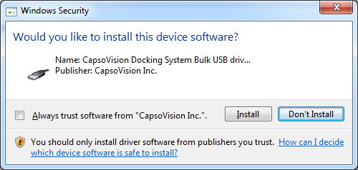
Make sure OS boot menu "Disable driver signature verification" option is NOT selected when booting, disable testsigning with command:
"bcdedit -set testsigning off"
Make sure driver is loaded successfully on Win7 64-bit.

